1. Figure below shows a grade report that is mailed to students at the end of each semester. Prepare an ERD reflecting the data contained in the grade report. Assume that each course is taught by one instructor. Explain what you choose for the identifier of each entity type on your ERD.

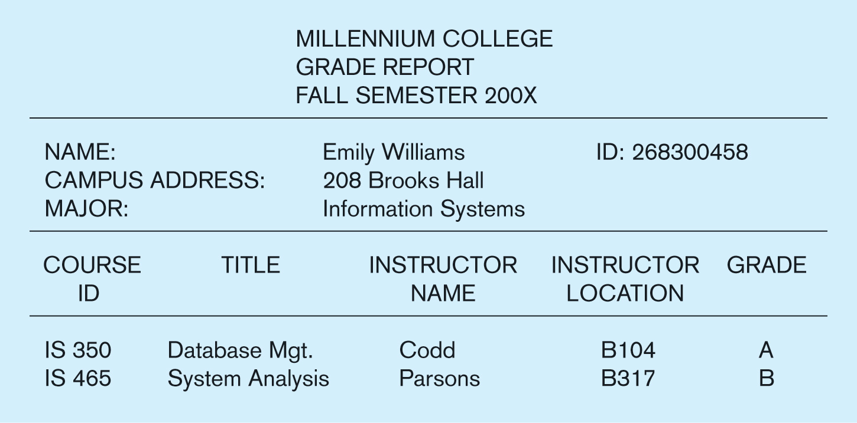

Student ID was chosen as the identifier for the STUDENT entity type as it is likely to be unique. Course ID was chosen as the identifier for the COURSE entity type as it is likely to be unique. Instructor Name was chosen as the identifier for the INSTRUCTOR entity type and it is assumed to be unique—should discussions during analysis work prove otherwise, it may be wise to create either (a) a composite identifier comprised of Instructor Name and Location, or (b) a new attribute Instructor ID that will be a unique number which can serve as an identifier.  
**Note**: The addition of Semester and Year attributes on the Registers for relationship allows this diagram (and resulting database) to reflect multiple semesters of data.



1. Consider the Is Married To relationship between the instances of PERSON entity. Draw a data model for the PERSON entity type and Is Married To relationship for each of the following variations by showing the appropriate cardinalities and including, if necessary, any attributes.
2. All we need to know is who a person is currently married to, if anyone.
3. We need to know who a person has ever been married to, if anyone.
4. We need to know who a person has ever been married to, if anyone, as well as the date of their marriage, and the date, if any, of the dissolution of their marriage.
5. The same situation as in c, but now assume that the same two people can remarry each other after a dissolution of a prior marriage to each other.



Diagram Notes for Problem & Exercise 2d:

* Two relationships defined between two entity types links two people who ever got married. Each instance of MARRIAGE entity is associated with two instances of PERSON entity.
* This solution presumes that Marriage Date is a partial identifier of the MARRIAGE entity; later in the design phase a full composite identifier will be created using Marriage Date and the two Person IDs involved in the marriage.
* The solution also assumes that the same two people do not get married, dissolved, and re-married on the same date. Adding a Marriage Time attribute (also a part of the identifier) would permit this situation to be covered by this model.
* An alternate solution would be to use a surrogate identifier of License No instead of the suggested composite identifier of Marriage Date and the two Person IDs for the MARRIAGE entity.



1. Draw an ERD for each of the following situations (If you believe that you need to make additional assumptions, clearly state them for each situation.)
   1. A company has a number of employees. The attributes of EMPLOYEE include Employee ID (identifier), Name, Address, and Birthdate. The company has also several projects. Attributes of PROJECT include Project ID (identifier), Project Name, and Start Date. Each employee may be assigned to one or more projects or may not be assigned to a project. A project must have at least one employee assigned and may have any number of employees assigned. An employee’s billing rate may vary by project, and the company wishes to record the applicable billing rate (Billing Rate) for each employee when assigned to a particular project.



Is Assigned To

* 1. A laboratory has several chemists who work on one or more projects. Chemists also may use certain kinds of equipment on each project. Attributes of CHEMIST include Employee ID(identifier), Name, Phone No. Attributes of PROJECT include Project ID(identifier) and Start Date. Attributes of EQUIPMENT include Serial No and Cost. The organization wishes to record Assign Date- that is, the date when a given equipment item was assigned to a particular chemist working on a specified project. A chemist must be assigned to at least one project and one equipment item. A given equipment item need not be assigned, and a given project need not be assigned either a chemist or an equipment item.



* 1. A college course may have one or more scheduled sections or may not have a scheduled section. Attributes of COURSE include Course ID, Course Name, and Units. Attributes of SECTION include Section Number and Semester ID. Semester ID is composed of two parts: Semester and Year. Section Number is an integer (such as 1 or 2) that distinguishes one section from another for the same course but does not uniquely identify a section. How did you model SECTION? Why did you choose this way versus alternative ways to model SECTION?



Diagram Notes for c**:** SECTION is modeled as a weak entity. It could have been modeled as a multivalued composite attribute of COURSE; however, using a weak entity is better, since SECTION may have a relationship with another entity, like INSTRUCTOR. A multivalued composite attribute could not be used to show this relationship.

* 1. A hospital has a large number of registered physicians. Attributes of PHYSICIAN include Physician ID (identifier) and Specialty. Patients are admitted to the hospital by physicians. Attributes of PATIENT includes Patient ID (identifier) and Patient Name. Any patient who is admitted must have exactly one admitting physician. A physician may optionally admit any number of patients. Once admitted, a given patient must be treated by at least one physician. A particular physician may treat any number of patients, or may not treat any patients. Whenever a patient is treated by a physician, the hospital wishes to record the details of the treatment (Treatment Detail). Components of Treatment Detail include Date, Time and Results. (i) Did you draw more than one relationship between physician and patient? Why or why not? (ii) Did you include hospital as an entity type? Why or why not? (iii) Does your ERD allow for the same patient to be admitted by different physicians over time? (iv) How would you include on the ERD the need to represent the date on which a patient is admitted for each time he or she is admitted?



Diagram Notes for d: (i) Both Admits and Treats relationships were created since the patient could be treated by other PHYSICIANs in addition to the admitting PHYSICIAN. (ii) Hospital was not included as an entity in this case as there was insufficient information in the scenario write-up to indicate that the data model needed to allow for multiple hospitals (e.g., in the case of a large health-care organization). (iii) The current ERD does not allow for the tracking of multiple admissions over time by different physicians. The ERD would need a many-to-many relationship between PHYSICIAN and PATIENT in order to track that kind of data. (iv) If the date of admission needs to be tracked, under the circumstances of tracking multiple admissions over time, the ERD could be revised to show Date Admitted as an attribute of the many-to-many Admits relationship, just as Treatment Detail is an attribute of the Treats relationship. The ERD could also be revised to show ADMISSION and TREATMENT DETAIL associative entities (with corresponding attributes) instead of the many-to-many relationships currently discussed.

* 1. The loan office in a bank receives from various parties requests to investigate the credit status of a customer. Each credit request is identified by a Request ID and is described by a Request Date and Requesting Party Name. The loan office also receives results of credit checks. A credit check is identified by a Credit Check ID and is described by the Credit Check Date and the Credit Rating. The loan office matches credit requests with credit check results. (i) A credit request may be recorded before its result arrives; a particular credit result may be used in support of several credit requests. Draw an ERD for this situation. (ii) Now assume that credit results may not be reused for multiple credit requests. Draw the ERD for this new situation using two entity types, and then redraw it again using one entity type. Which of these versions do you prefer, and why?

First situation: credit check can be used by more than 1 request.





Using 1 entity type seems much simpler since the credit check and rating only apply to this credit request. However, Credit Check Date and Credit Rating will have blank values (null) until the credit check is received.

* 1. Companies, identified by Company ID and described by Company Name and Industry Type, hire consultants, identified by Consultant ID, and described by Consultant Name and Consultant Specialty, which is multivalued. (i) Assume that a consultant can work for only one company at a time, and we need to track only current consulting engagements. Draw an ERD for this situation. (ii) Now consider a new attribute, Hourly Rate which is the rate a consultant charges a company for each hour of his or her services. Redraw the ERD to include this new attribute. (iii) Now consider that each time a consultant works for a company, a contract is written describing the terms for this consulting engagement. Contract is identified by a composite identifier of Company ID, Consultant ID, and Contract Date. Assuming a consultant can still work for only one company at a time, redraw the ERD for this new situation. Did you move any attributes to different entity types in this latest situation? (iv) As a final situation, now consider that although a consultant can work for only one company at a time, now we need to keep the complete history of all consulting engagements for each consultant and company. Draw an ERD for this final situation. Explain why these different changes to the situation led to different data models, if they did.

(i) - Tracking current consulting engagements.



(ii) – Adding Hourly Rate attribute. This could be added to the CONSULTANT entity if the business rule is that a CONSULTANT Works for only 1 COMPANY at a time.



(iii) – Tracking a CONSULTANT’s contract. Notice that CONTRACT is added as another entity that participates in a binary relationship with COMPANY and a binary relationship with CONSULTANT. We have moved the Hourly Rate attribute to the CONTRACT entity, which permits a CONSULTANT to vary his/her Hourly Rate as a function of the particular CONTRACT for a COMPANY. As only current CONTRACTs are tracked, an alternative solution would be to move the CONSULTANT attributes into the CONTRACT entity and eliminate the CONSULTANT entity from the model.



(iv) – Tracking historical CONTRACT information. We can create an associative entity for CONTRACT. We’ve also added Contract ID as a surrogate identifier that is a unique serial number (not a composite identifier, as shown in (iii) above).



* 1. An art museum owns a large volume of works of art. Each work of art is described by an item code (identifier), title, type, and size; size is further composed of height, width, and weight. A work of art is developed by an artist, but the artist for some works is unknown. An artist is described by an artist ID (identifier), name, date of birth, and date of death (which is null for some living artists). Only data about artists for works currently owned by the museum are kept in the database. At any point in time, a work of art is either on display at the museum, held in storage, away from the museum, as part of a traveling show, or on loan to another gallery. If on display at the museum, a work of art is also described by its location within the museum. A traveling show is described by a show ID (identifier), the city in which the show is currently appearing, and the start and end dates of the show. Many of the museum works may be part of a given show, and only active shows with at least one museum work of art need to be represented in the database. Finally, another gallery is described by gallery ID (identifier), name, and city. The museum wants a complete history of a loaning a work of art to other galleries, and each time a work is loaned, the museum wants to know the date the work was loaned and the date it was returned. As you develop the ERD for this problem, follow good data naming guidelines.



Diagram Notes for Problem & Exercise g:

* ARTWORK is created by 0:1 ARTIST (0 for Unknown ARTIST); alternative design would be to have a valid ARTIST instance with a Name of “Unknown”; this would enable you to enforce a business rule that each piece of ARTWORK must have an ARTIST stored in the database and the cardinality would change to mandatory 1 near the ARTIST entity in the diagram.
* Item Status attribute of ARTWORK permits designation of ARTWORK as Display (and then a valid value for Item Museum Location attribute), Storage, Loan, or Show.
* An ARTWORK item may participate in a SHOW; however, there is not a way to note on the ERD that an ARTWORK item cannot be a part of two shows with overlapping dates. This business constraint will need to be noted as part of the system design documentation.

1. Wally Los Gatos, owner of Wally’s Wonderful World of Wallcoverings, has hired you as a consultant to design a database for his chain of three stores that sell wallpaper and accessories. He would like to track sales, customers, and employees. After an initial meeting with Waley, you have developed a list of business rules and specifications to begin the design of an ER model:

* Customers place orders through a branch.
* Wally would like to track the following about customers: Name, Address, City, State, Zip Code, Telephone, Date of Birth, and Primary Language.
* A customer may place many orders.
* A customer does not always have to order through the same branch all the time
* Customers may have one or more accounts, although they may also have no accounts.
* The following information needs to be recorded about accounts: Balance, Last Payment date, Last payment amount, and Type.
* A branch may have many customers.
* The following information about each branch needs to be recorded: Branch Number, Location (Address, City, State, Zip Code), and Square Footage.
* A branch may sell all items or may only sell certain items.
* Orders are composed of one or more items.
* The following information about each order needs to be recorded: Order Date and Credit Authorization Status.
* Items may be sold by one or more branches.
* We wish to record the following about each item: Description, Color, Size, Pattern, and Type.
* An item can be composed of multiple items; for example, a dining room wallcovering set (item 20) may consist of wallpaper (item 22) and borders (item 23).
* Wally employs 56 employees.
* He would like to track the following information about employees: Name, Address (Street, City, State, Zip Code), Telephone, Date of Hire, Title, Salary, Skill, and Age.
* Each employee works in one and only one branch.
* Each employee may have one or more dependents. We wish to record the name of the dependent as well as the age and relationship.
* Employees can have one or more skills.

Based upon this information, draw an ER diagram. Indicate any assumption that you have made.



1. For a library, the entity type HOLDING has four subtypes: BOOK, AUDIO BOOK, DVD, and SOFTWARE. Draw a separate EER diagram segment for each of the following situations:
2. At a given time, a holding must be exactly one of these subtypes.

*A holding is exactly one subtype*



1. A holding may or may not be one of these subtypes. However, a holding that is one of these subtypes cannot at the same time be one of the other subtypes.

*A holding may or may not be a subtype; but only one subtype at a time*



1. A holding may or may not be one of these subtypes. On the other hand, a holding may be any two (or even four) of these subtypes at the same time.

*A holding may or may not be a subtype; but can be more than 1 at a time.*



1. At a given, a holding must be at least one of these subtypes.

*A holding must be a subtype; but can be more than 1 at a time.*



1. Draw an EER diagram for the following problem using the textbook’s EER notation. Add a subtype discriminator (named Person Type) to the diagram you created.

A nonprofit organization depends on a number of different types of persons for its successful operation. The organization is interested in the following attributes for all of these persons: SSN, Name, Address, City, State, Zip, and Telephone. Three types of persons are of greatest interest: employees, volunteers, and donors. Employees have only a Date Hired attribute, and volunteers have only a Skill attribute. Donors have only a relationship (named Donates) with an Item entity type. A donor must have donated one or more items, and an item may have no donors, or one or more donors. There are persons other than employees, volunteers, and donors who are of interest to the organization so that a person need not belong to any of these three groups. On the other hand, at a given time a person may belong to two or more of these groups (e.g. employee and donor).

**Note**: We have assumed that Skill is a multivalued attribute.



1. Draw an EER diagram for the following problem using the textbook’s EER notation.

A technology company provides offerings to its customers. Offerings are of two separate types: products and services. Offerings are identified by an offering ID and an attribute of description. In addition, products are described by product name, standard price, and date of first release; services are described by name of the company’s unit responsible for the service and conditions of service. There are repair, maintenance, and other types of services. A repair service has a cost and is the repair of a specific product; a maintenance service has an hourly rate. Each product has at least one repair service offered. However, there are many repair services available for a product. A customer may purchase an offering, and the company needs to keep track of when the offering was purchased and the contact person for that offering with the customer. Unfortunately, not all offerings are purchased. Customers are identified by customer ID and have descriptive data of name, address, and phone number. When a service is performed, that service is billed to some customer. Because some customers purchase offerings for their clients, a customer may be billed for services he did not purchase. When a customer is billed for a service (although some may never require a service of any type), the company needs to keep track of the date the service was performed, the date the bill is due, and the amount due.

